Research Grant Status Tracker

Customer: Prof. Malek-Madani

Advisor: LCDR Kenney

Apps Linking Midshipmen and Officers

Team 6

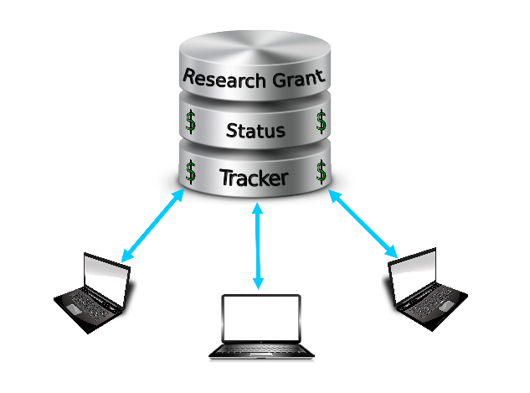

Nick Arnold - IT

Sam Coons - CS

Scott Gibson - CS/QE

Pullig, Brandon - CS/IT

Hall, Micky - CS/IT (Team Leader)

Capstone Proposal - Initial Draft